**Software Requirements and Design Document**

**For**

**Group 2**

Version 1.0

**Authors**:

Kendall Fretwell

Miles Brosz

Grant Leatherman

Caroline Mangrum

Joseph Riley

# Overview (5 points)

*The system consists of an app that allows users to connect to the host. The host is allowed to tweak the game’s settings to their liking. Upon connecting to the host, the players are able to partake in a 1v1 where they are given a few options to select from. They can create a wall, dig, or use a weapon. They are able to draw the move they want to do after selecting it. They are able to draw for 15-30 seconds depending on the host’s settings. Each character is able to move if they choose to. Weapons and character options can manipulate the terrain.*

# Functional Requirements (10 points)

*1. Multiplayer - high*

*2. Terrain manipulation - medium*

*3.Movement - medium*

*4.Turns - low*

*5. Stretching – high*

*6. Animations - medium*

# Non-functional Requirements (10 points)

*1. UI – will become a main focus once the base game works*

# Use Case Diagram (10 points)

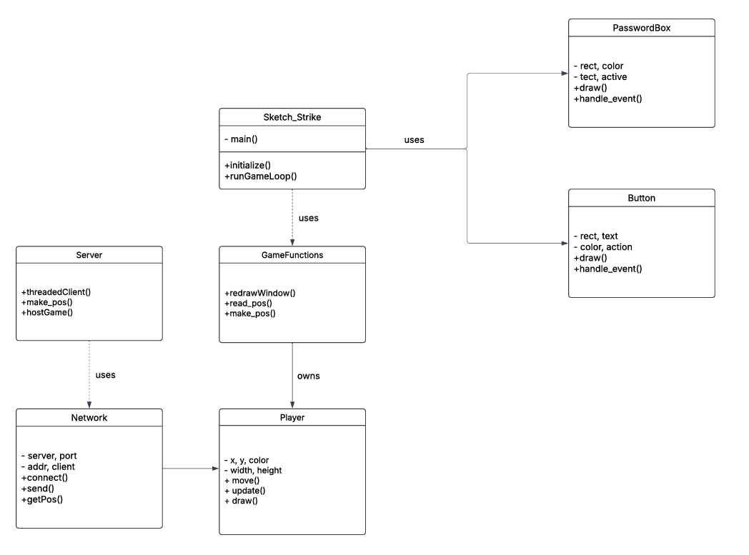

# Class Diagram and/or Sequence Diagrams (15 points)

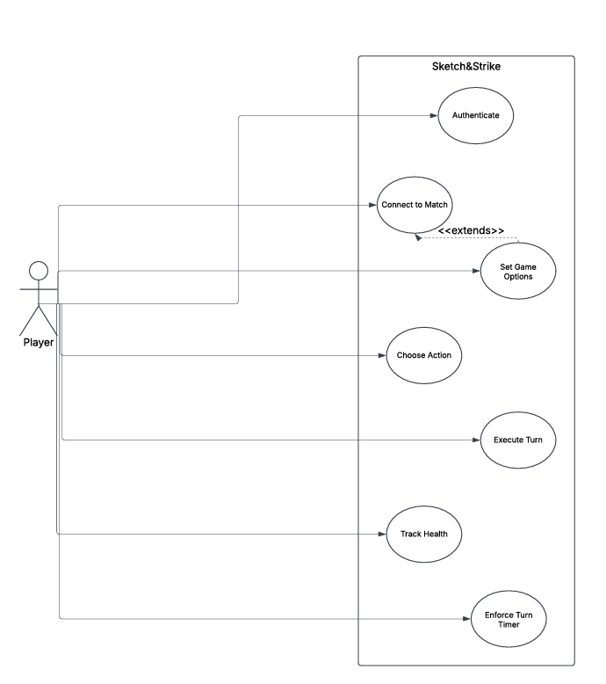

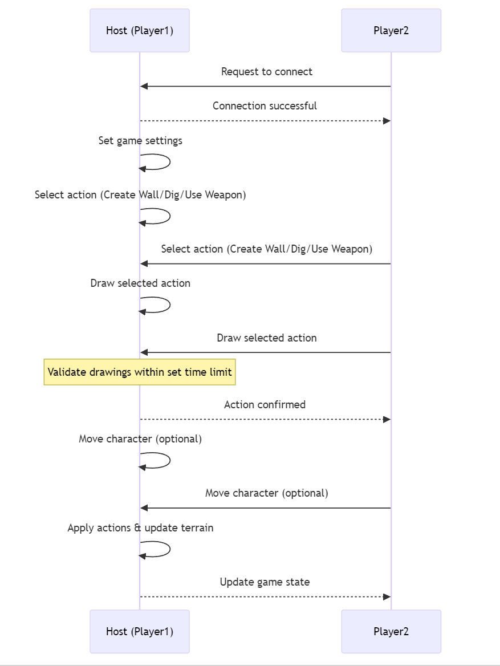

# Operating Environment (5 points)

*It should be able to work on windows, macOS, and Linux. Players should be able to connect to each other regardless of their operating system as long as they have the game downloaded.*

# Assumptions and Dependencies (5 points)

There are no known factors that could affect the requirements.